University of Maryland, Baltimore County
Department of Information Systems
Anish Kandel
MGMT 489 - Independent Study
Dr. Karen Chen
December 17, 2025
Data Storytelling for Operational Decision-Making Using Server Performance Metrics

Source1: https://www.kaggle.com/datasets/omnamahshivai/dataset-system-resources-cpu-ram-disk-network?
Source 2: https://www.acceldata.io/blog/data-storytelling-how-to-turn-raw-data-into-business-action?

- Source Acknowledgments

The article titled Data Storytelling: How to Turn Raw Data into Business Action published by Acceldata serves as the basis of this case study and highlights the significance of converting the operational metrics into the form of narratives that will lead to prompt and prudent decision-making. Instead of emphasizing on fixed dashboards or technical records, the article provides the importance of storytelling in organisations to convey the health of the systems, identify risks in time, and align technical knowledge with business performance.

To justify this strategy, this case study refers to publicly available Server Performance Metrics data obtained at Kaggle. The data set contains time based operational data like CPU usage, memory usage, disk activity, and network metrics on the server instances. The data is used without any simulation and all the visualisations and interpretations are based on the real-world data of operational work. It provides a Jupyter Notebook which shows the transparency and reproducibility of the analysis.

- Business / Organizational Context.

The contemporary organisations are extensively dependent on the digital infrastructure to provide services, conduct transactions, and facilitate the day-to-day operations. Cloud-based applications to internal enterprise applications, the performance of the server has a direct impact on customer experience, the performance of the business, and business continuity. As a result, organisations are constantly gathering massive amounts of system-level monitoring data, such as CPU usage, memory usage, network usage, and disk usage.

Although this data is available, most organisations have difficulties turning raw metrics into practical insight. Performance dashboards will flood the user with numbers, whereas alerts will make them react without giving context. This creates a reactive environment where the teams react to incidences after the service degradation has already taken place.

Acceldata article claims that data storytelling is what is lacking between monitoring and action. Telling a story around operational data (with an emphasis on trends and anomalies, thresholds and effects) enables teams to cognitively engage with what is going on and why it is important and what next action is necessary. The case study uses that concept in reference to the server performance metrics where operational knowledge can be converted into knowledge aimed at proactive decision-making.

- Communication Goal

The main goal of the case study is to show how to use the principles of data storytelling to transform the information about the performance of the servers into a clear, actionable narrative. This analysis is an attempt to demonstrate how analysis of trends and anomalies can assist technical and non-technical users to understand business risk and system behaviour by viewing system metrics as more than merely technical indicators.

In particular, the case study aims at:

* Determine trends in system performance with time.
* Identify indicators of decreased performance at an early stage.
Link technical measures to operational effect.
* Show how narration can enhance IT and business leadership contact.

- Audience

The case study will be targeted at IT operations managers, site reliability engineers (SREs) and system administrators who are in charge of ensuring infrastructure reliability. It can also be applied to product managers, business leaders as well as analysts who rely on the availability of the systems but do not necessarily work directly with technical metrics. Moreover, the case study is a learning example that can be used by students and professionals who wish to put data storytelling techniques to use in operational and infrastructure data.

- Key Story Elements / Narrative Structure.

This case study is organized based on the simple operational narrative in accordance with the principles of the storytelling of Acceldata:

Context: The servers perform in normal conditions and are expected to perform within the expected performance ranges.
Tension: The performance measures start to exhibit abnormal trends or limit violations.
Insight: Visual analysis gives an insight into the trends or anomalies that indicate a problem.
Action: Insights are used to make decisions in order to take action before failures.
Outcome: Stability of the system and minimization of the operational risk.

This design has the benefit of making every visualisation part of a larger narrative and not standing alone.

- Data and Visualisation Method.

The data of the server performance that was used in this case study consists of time-based metrics which are naturally suitable to visual storytelling. I concentrate on easy-to-read charts with Jupyter Notebook, like a line graph and threshold-based comparison, to point out system behaviour changes with time.

Instead of using complicated statistical models, the focus is on the clarity and relevancy. Each visualisation is structured to provide answers to a certain operational question and contribute to the overall narrative of the proactive monitoring and decision-making.

Question 1: What does “normal” CPU behavior look like over time, and are there spikes that signal instability?

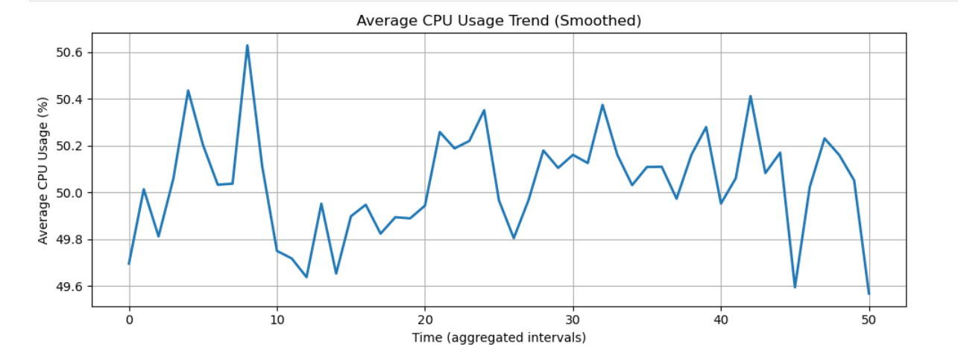

The smooth trend of the CPU utilization means that the operating environment is healthy and stable, with utilization values maintained at 50% and with slight time changes only. This trend is an indication of a consistent workload as opposed to sporadic explosions or drops in performance, and it means that the servers are being used effectively to handle the demand. The absence of sharp peaks or dales is an indication of proper infrastructure management, in which resources are not overworked or were not underused. Businesswise, such stability gives a sense of confidence in the performance of the existing systems besides also exposing areas of optimization thus opportunities to increase efficiency or capacity in future expansions without necessarily having to invest more at the moment.

Q2 (Memory Risk): Is memory usage stable, or does it steadily climb (possible leak / capacity risk)?

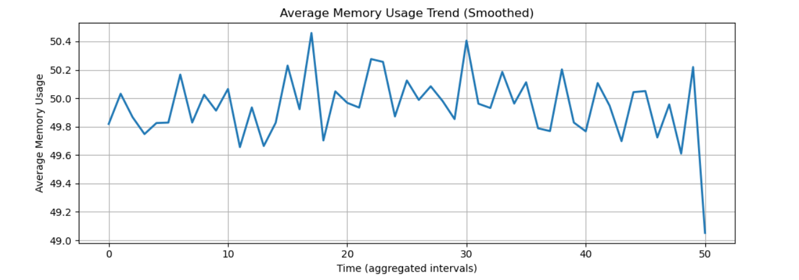
The flattened memory usage curve shows a steady, well-managed pattern, the consumption always wonders at 50 percent, and minimal, temporal sporadic fluctuations. There is no long-term upward trend, so there is no sign of a memory leak or any increasing capacity building. Several slight spikes and dips indicate natural variability in work loads and no structural problems are detected. All in all, this visualization shows that the use of memory resources is efficient, and it is in line with system demand, which is an assurance that the existing memory capacity is adequate and does not present an operational threat in the near future.

Q.3. When CPU usage increases, does memory usage also increase (meaning the same workload is stressing both), or are they mostly independent?

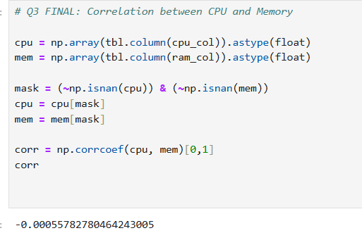

The correlation coefficient between the CPU and memory use is practically equal to zero (0.00056), which means that there is no significant correlation between the two resources in this system. In practice, this implies that no systematic increase in CPU utilization is associated with systematic increase in memory utilization, and the reverse. This implies a balanced workload whereby other processes demand other resources singly, and not in a compounded performance stress. Operationally, and in terms of business, this is good news: the infrastructure is not being limited by one kind of workload, and scaling or optimization choices are possible with specificity (CPU or memory) and does not require complex and expensive system-wide upgrades.

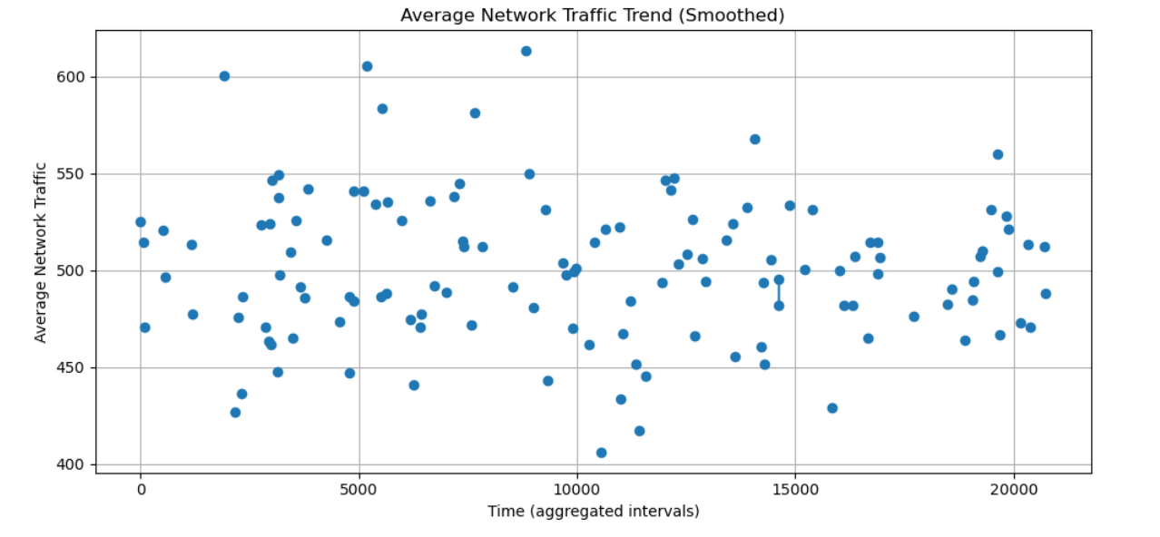
Q.4. Are there sustained spikes in network traffic that could indicate I/O or data-transfer bottlenecks over time?

The visualization also indicates that the average network traffic is relatively stable with time variations to fit in a constant range as opposed to the sharp upward and downward trends. Spike and dips that happen periodically seem to be short-lived and do not last over the long period of time meaning that bursts of data transfer may be caused by certain workloads or tasks as opposed to congestion in the system. Notably, the lack of an increasing trend shows that network bottlenecks in the system do not increase with time. As an operational matter this implies that the workload being processed is normally within the current capacity of the network, but peaks can still be of interest to monitor so as to avoid overlaps with the latency-sensitive or higher-priority work.

Q.5. “When CPU load increases, does power consumption rise too — and is the relationship strong enough to matter for cost/efficiency decisions?”
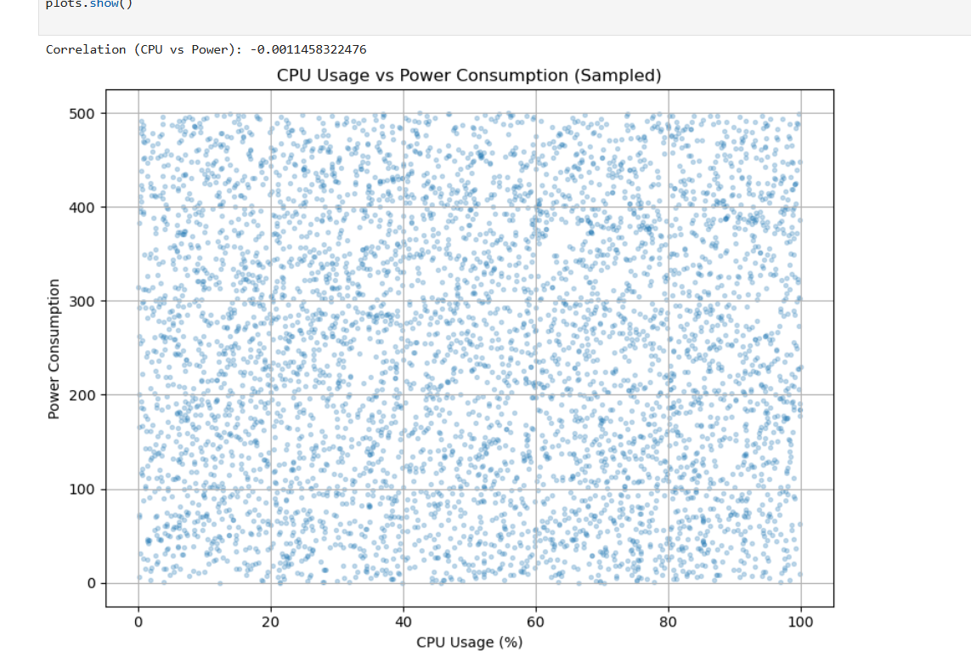

This visualization shows that CPU use and power consumption do not show any direct correlation here. Scatter plot shows that the dispersion is broad and there is no apparent trend whether positive or negative and the correlation coefficient (0.001) validates this quantitatively. In practice, the growth in CPU use does not always translate to increased power consumption, creating the idea that power consumption depends on other elements, including background tasks, type of workload, efficiency of the hardware, or power administration on the system level. Business and operationally, this means that even optimization on the use of Cpu may not give significant energy savings. Rather, workload scheduling, hardware optimization, and energy-efficient infrastructure policies should be aimed at by organizations in controlling costs of power in a better way.

Q6. What does the distribution of CPU usage look like across all server records?

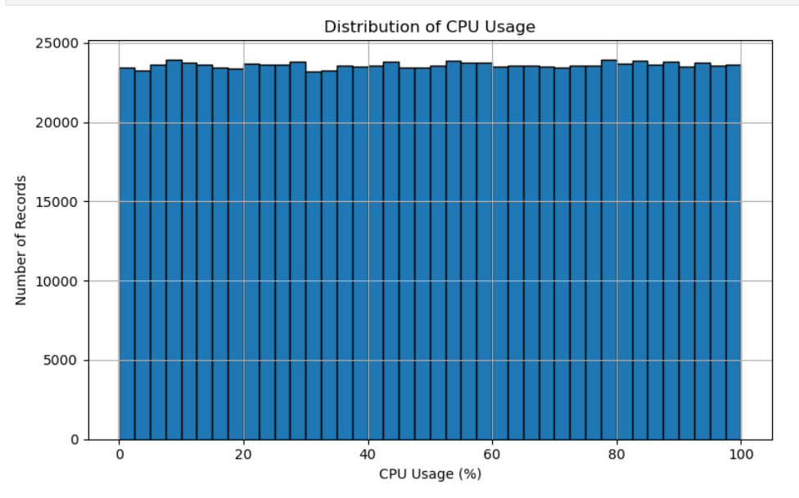

The histogram shows that CPU activity is not concentrated on low or high values, but it is distributed uniformly around the whole range of 0-100%. Simply put, the system is subjected to a load on all levels of CPU with a similar frequency. The peak is not sharply defined and indicates a dominating normal operating range, nor is the tail sharply defined to indicate frequent overloads and idle periods. Performance wise, this implies that the workload is very diverse and synthetic and probably produced to represent various operating conditions as opposed to a naturally occurring production system. This is strategically important so that averages by themselves are not very informative to decision-making, but rather that capacity planning and alerting should be based on threshold-based monitoring (e.g. sustained CPU above 80%) and tail behaviour (extreme high-usage events), as the system is deliberately subjected to all load levels. This distribution is handy when the infrastructure is being tested under stress, however, in a realistic business scenario, a more concentrated distribution would be anticipated.

Q.7. How efficient is the system in terms of energy usage?
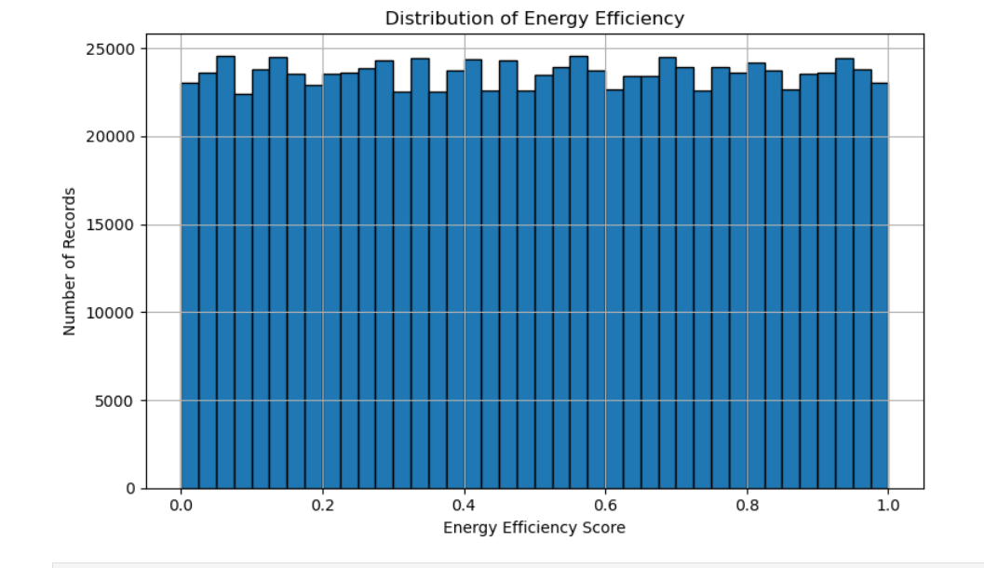

This histogram indicates that the distribution of scores in the energy efficiency is almost evenly spread all the way along the 0-1 range, there was no heavy concentration on the lower side or the higher side. In practice this means that the system works at all levels of efficiency in a balanced manner, and does not always work in an energy-efficient or energy-inefficient state. Analytically, this trend is indicative that the energy efficiency measure is artificially or evenly produced, and would tend to be indicative of a large spectrum of operating conditions rather than indicative of optimization behaviour. In the case of business or operational strategy, this means that average energy efficiency is not a good signal to base a decision on, but rather meaningful information would be obtained by relating efficiency to other variables such as CPU usage, type of task, or power consumption to determine under what circumstances efficiency will increase or decrease. This distribution is useful in the testing of energy-constrained policies, although in practical production context, a more skewed distribution would usually reflect on optimisation benefits, or systemic inefficiencies.

Business Strategy

The system performance analysis reveals that the infrastructure presents a stable and balanced condition, and the usage of the CPU, memory, and energy use are equalised throughout the analysed time. The fact that there are no sharp peaks or the excessive load indicates that the current carrying capacity can sustain the current workload without any urgent scaling investments. Business wise this stability is an opportunity of maximising the operations instead of over expanding the infrastructure before it is required.

Considering the comparatively homogeneous distribution of the utilisation of the resources, a strategic emphasis should be moved off the average utilisation metrics on the exception-based monitoring. Instead of responding to regular variations, the organisation must be keen on identifying anomalies like the sudden spike in CPU usage, or unfamiliar energy inefficiency, or unfamiliar execution time patterns which can reflect emerging system problems or security vulnerabilities. This will allow the technical departments to interfere early and reduce unnecessary costs of operation.

Also, the relative deficiency of strong correlations among the system metrics implies that workloads are heterogeneous and optimally distributed, as a result, the existence of single-resource bottlenecks is diminished. This fact confirms the ongoing use of load-balancing and task-scheduling systems and at the same time offers the flexibility that can be used to add more compute-intensive tasks without impacting the system unfavourably. This enables the business to add any specialised resources strategically, when there is a consistent breach of certain performance thresholds.

References

https://www.acceldata.io/blog/data-storytelling-how-to-turn-raw-data-into-business-action?
OpenAI. (2025). ChatGPT (October 2025 version) [Large language model]. Used for coding assistance and data visualization guidance in Python. https://chat.openai.com
Project Jupyter. (2015). Jupyter Notebook [Computer software]. https://jupyter.org

